University Admissions

Archivum, University of South Florida



1875 Explorer Street, 4th Floor | Reston, VA 20190

T 703.442.8844 | F 703.442.8919

[www.appian.com](http://www.appian.com)

# Table of Contents

Table of Contents 1

1. Business Value 7

2. Introduction 7

2.1. Intended Audience 7

2.2. Scope 7

2.3. Organization 8

2.4. Further Documentation 8

3. Process Architecture 8

3.1. Main Processes 9

**3.1.1.** **UAP Manage Groups & Preferences** 9

3.1.1.1. UAP Manage Program 9

3.1.1.2. UAP Manage Designees 9

**3.1.2.** **Related Actions: Updating the Application** 10

3.1.2.1. Add Note 10

3.1.2.2. Faculty Review 10

3.1.2.3. Missing Documents Email 10

3.1.2.4. Update Application 11

3.1.2.5. Expose Reviews 11

**3.1.2.6.** **Graduate Admissions Dashboard** 12

3.1.2.6.1. Director Dashboard 12

3.1.2.6.2. Faculty Reviewer Dashboard 13

3.1.2.6.3. Graduate Admissions Coordinator Dashboard 13

1. Development Patterns 14

1.1. Background Information 14

**1.1.1.** **Process Model and Rule Folder Structure** 14

1.1.1.1. Process Models 14

1.1.1.2. Rules 14

1.1.1.3. Collaboration 14

1.1.1.4. Naming Conventions 14

1.2. Quick Reference Guide 16

2. Plugins 18

2.1. Existing 18

**2.1.1.** **AdvancedDocumentTemplating** 18

**2.1.2.** **Group Management Plugin** 18

**2.1.3.** **PDF Tools** 18

**2.1.5.** **Add Documents to Zip** 19

**2.1.6.** **Data Collection features of Appian Health Check** 19

**2.1.7.** **Object Information Retriever** 19

**2.1.8.** **Appian Regular Expression Function** 19

**2.1.9.** **Business Value Framework Plugin Framework** 20

**2.1.10.** **Content Expressions** 20

**2.1.11.** **Crypotography** 20

2.2. Custom 21

2.2.1. No custom plugins were used for this application. 21

3. Data Design 21

3.1. High Level Data Design 21

3.2. UAP Data Design 21

4. Groups 22

4.1. UAP All Users 23

**4.1.1.** **Description** 23

**4.1.2.** **Inherited Roles** 23

**4.1.3.** **Permissions** 23

4.1.3.1. Actions 23

4.1.3.2. Related Actions 23

4.1.3.2.1. Add Note 23

4.1.3.3. Record Views 23

4.1.3.4. Reports 23

4.2. UAP College Designee Managers 23

**4.2.1.** **Description** 23

**4.2.2.** **Inherited Roles** 24

4.2.2.1. UAP All Users 24

**4.2.3.** **Permissions** 24

4.2.3.1. Actions 24

4.2.3.1.1. Manage Designees 24

4.2.3.2. Related Actions 24

4.2.3.3. Record Views 24

4.2.3.4. Reports 24

4.3. Graduate Admissions College Designees 24

**4.3.1.** **Description** 24

**4.3.2.** **Inherited Roles** 25

4.3.2.1. UAP All Users 25

**4.3.3.** **Permissions** 25

4.3.3.1. Actions 25

4.3.3.1.1. Manage Program Preferences 25

4.3.3.2. Related Actions 25

4.3.3.2.1. Add Note 25

4.3.3.2.2. Missing Documents Email 25

4.3.3.2.3. Update Application 25

4.3.3.3. Record Views 25

4.3.3.3.1. Graduate Applications 25

4.3.3.4. Reports 25

4.4. UAP Graduate Admissions Coordinators 25

**4.4.1.** **Description** 25

**4.4.2.** **Inherited Roles** 26

4.4.2.1. UAP All Users 26

**4.4.3.** **Permissions** 26

4.4.3.1. Actions 26

4.4.3.1.1. Manage Admissions Groups & Preferences 26

4.4.3.2. Related Actions 26

4.4.3.2.1. Add Note 26

4.4.3.2.2. Missing Documents Email 26

4.4.3.2.3. Update Application 26

4.4.3.3. Record Views 26

4.4.3.3.1. Graduate Applications 26

4.4.3.4. Reports 26

4.4.3.4.1. Graduate Admissions Dashboard 26

4.5. UAP Faculty 27

**4.5.1.** **Description** 27

**4.5.2.** **Inherited Roles** 27

4.5.2.1. UAP All Users 27

**4.5.3.** **Permissions** 27

4.5.3.1. Actions 27

4.5.3.1.1. Manage Designees 27

4.5.3.2. Related Actions 27

4.5.3.2.1. Add Note 27

4.5.3.2.2. Faculty Review 27

4.5.3.3. Record Views 27

4.5.3.3.1. Graduate Applications 27

4.5.3.4. Reports 27

4.5.3.4.1. Graduate Admissions Dashboard 27

4.6. UAP Faculty Reviewers 28

**4.6.1.** **Description** 28

**4.6.2.** **Inherited Roles** 28

4.6.2.1. UAP All Users 28

**4.6.3.** **Permissions** 28

4.6.3.1. Actions 28

4.6.3.2. Related Actions 28

4.6.3.2.1. Add Note 28

4.6.3.2.2. Faculty Review 28

4.6.3.3. Record Views 28

4.6.3.3.1. Graduate Applications 28

4.6.3.4. Reports 28

4.6.3.4.1. Graduate Admissions Dashboard 28

4.7. UAP Program Directors 29

**4.7.1.** **Description** 29

**4.7.2.** **Inherited Roles** 29

4.7.2.1. UAP All Users 29

**4.7.3.** **Permissions** 29

4.7.3.1. Actions 29

4.7.3.1.1. Manage Program Preferences 29

4.7.3.2. Related Actions 29

4.7.3.2.1. Add Note 29

4.7.3.2.2. Director Recommendation 29

4.7.3.2.3. Expose Review 29

4.7.3.2.4. Missing Documents Email 29

4.7.3.2.5. Update Application 29

4.7.3.3. Record Views 30

4.7.3.3.1. Graduate Applications 30

4.7.3.4. Reports 30

4.7.3.4.1. Graduate Admissions dashboard 30

4.8. UAP Application Alerts 30

**4.8.1.** **Description** 30

**4.8.2.** **Inherited Roles** 30

4.8.2.1. UAP All Users 30

**4.8.3.** **Permissions** 30

4.8.3.1. Actions 30

4.8.3.2. Related Actions 30

4.8.3.3. Record Views 30

4.8.3.4. Reports 30

4.9. UAP Application Administrators 31

**4.9.1.** **Description** 31

**4.9.2.** **Inherited Roles** 31

4.9.2.1. UAP All Users 31

**4.9.3.** **Permissions** 31

4.9.3.1. Actions 31

4.9.3.1.1. Manage Designee 31

4.9.3.2. Related Actions 31

4.9.3.2.1. Add Note 31

4.9.3.2.2. Faculty Review 31

4.9.3.3. Record Views 31

4.9.3.3.1. Groups 31

4.9.3.4. Reports 32

4.9.3.4.1. Graduate Admissions dashboard 32

5. UX Patterns 32

5.1. Action Buttons on Dashboards 32

5.2. Reports & Charts 32

5.3. Dynamic Email Names 33

5.4. Collapsible Sections 33

6. Integrations 34

6.1. Get Prior Institutions 34

6.1.1. Description 34

6.1.2. Inputs 34

6.1.3. Outputs 34

6.2. Get Test Scores 35

6.2.1. Description 35

6.2.2. Inputs 35

6.2.3. Outputs 35

6.3. Get Document Meta Data 36

6.3.1. Description 36

6.3.2. Inputs 36

6.3.3. Outputs 36

6.4. Get Document 37

6.4.1. Description 37

6.4.2 Inputs 37

6.4.3 Outputs 38

6.5 Post Admission Decisions 38

6.5.1 Description 38

6.5.2 Inputs 38

6.5.3 Output 39

7. Technical FAQS 39

7.1 How do I assign Users to the Proper Groups? 39

7.2 Reference Table 40

7.3 Security 40

# Business Value

The purpose of this system, for phase one, is to give USF Graduate Admissions and graduate department programs a tool to improve customer service for graduate applicants. The main goal is to improve the time to reach a decision on an applicant, and in turn, improve overall enrollment yield. This system supports employee, and student success, and is in alignment with USF’s strategic goal to secure top graduate research talent.

Below are metrics provided by the Graduate Admission team:



# Introduction

## Intended Audience

This document is primarily intended for the implementation team. It contains technical information and Appian best practices to be used to configure and implement the process artifacts and the user interfaces for the University Admissions Process (UAP).

This document describes the proposed high-level design recommendations and best practices for the Graduate Admissions process. The application will be referred to as the UAP within this document.

## Scope

The scope of the Appian Architecture Document is to provide design and best practice recommendations in the following areas:

* High level process architecture
* Web service patterns
* Development patterns (Naming conventions, folder structure)
* Plugins
* High level data design
* Group Structure
* User Experience (UX) Patterns

## Organization

The following sections describe the high-level architecture and behavior of the UAP. The components are documented for implementation within Appian for the UAP. If other applications are added in the future, some global folders and settings should be added. The sections below will use Appian terminology.

Each section contains:

1. A brief introductory paragraph that explains the area
2. Specific recommendations for the UAP

## Further Documentation

Upon completion of the system, the Appian Process Model Documentation is always available throughout the development cycle to document the application at a more detailed level. The Process Model Documentation view displays a report of the process model design and the objects it contains. Links displayed on the report provide the details for the selected object. The report provides the following details.

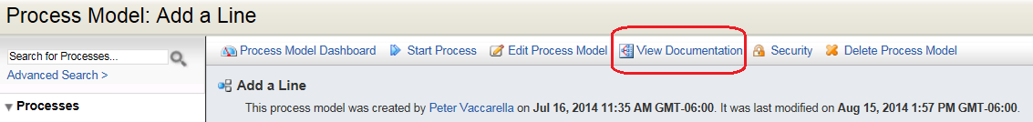

* Process model properties
* A Business Process Modeling Notation (BPMN) view of the process model
* Properties for each activity, event, and gateway
* Swimlane properties
* Annotations
* Process flow connection properties

# Process Architecture

This section presents the high-level process hierarchy for the application. In most cases, the individual components in the process diagram will not correspond to individual nodes (though they may); rather, the components are higher level units intended to depict the process hierarchy, architecture and workflow. The Appian process model translation of each step may be implemented by several individual nodes or sub-processes in the final application. In the UAP application the majority of the processes are contained in the “Graduate Admissions” Record of Archivum, with the Managing of Departmental preferences, occurring in the “Actions” tab in Tempo.

## Main Processes

### **UAP Manage Groups & Preferences**

The Manage Groups and Preferences allows specific users to update members of the respective Graduate Programs.

* + - 1. UAP Manage Program

The Process Model utilized for updating Program Directors, Faculty Reviewers, and Program Preferences.

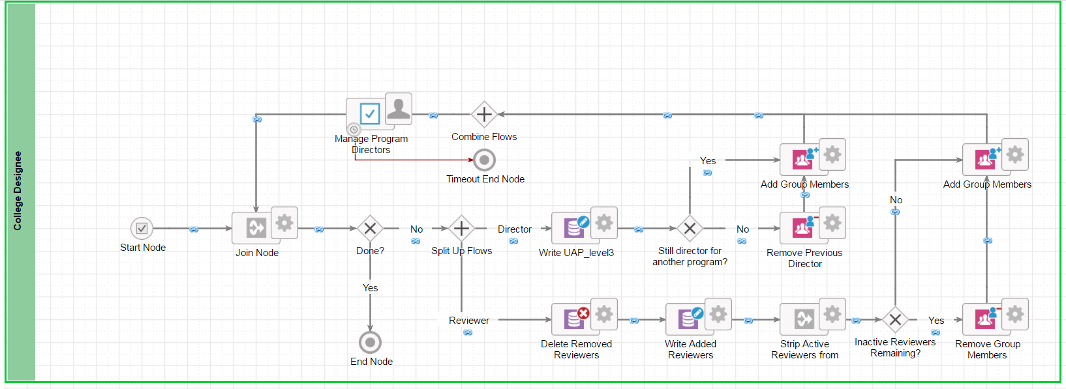

* + - 1. UAP Manage Designees

A process model for UAP College Designee Managers to manage College Designees members.

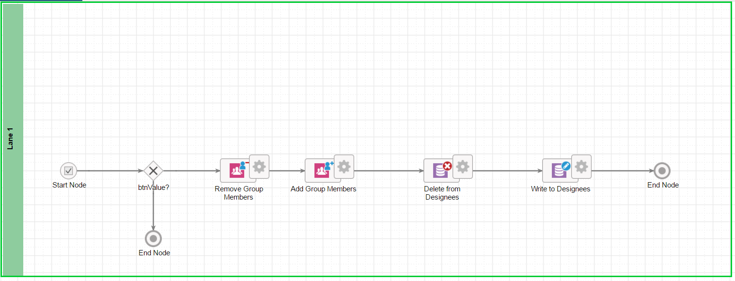

### **Related Actions: Updating the Application**

Applicants of the Graduate Admissions are updated via related actions within the Graduate Admissions Record. The related actions allow specific Admissions users to modify applicant information.

* + - 1. Add Note

Allow all users to add notes to an application.

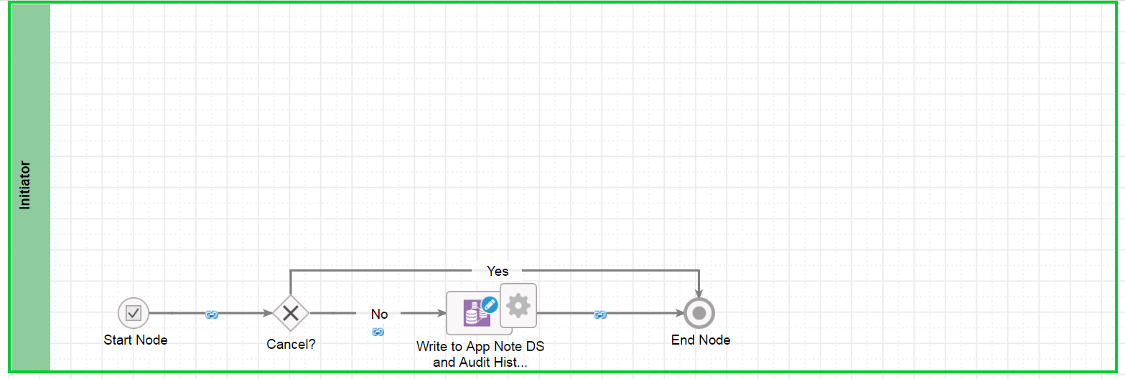

* + - 1. Faculty Review

Allows the specified faculty review, outlined by the respective Designee Mangers, to add their review for an applicant.

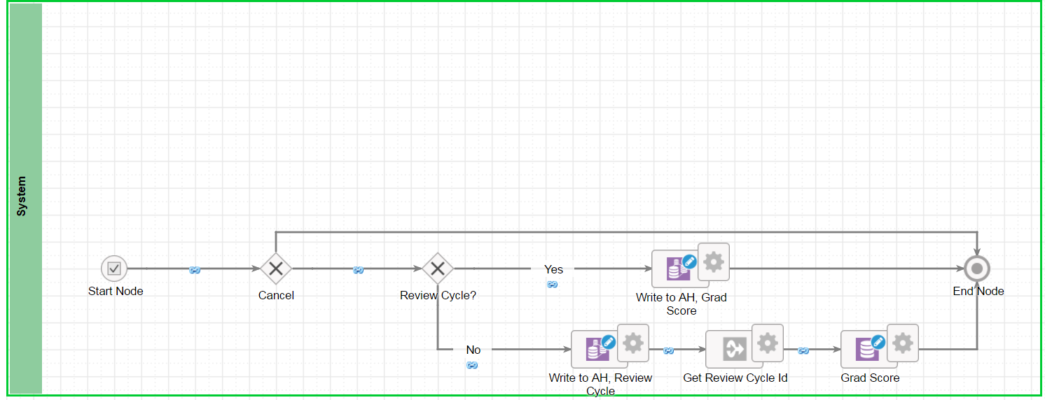

* + - 1. Missing Documents Email

The Missing Documents Email Process Model allow the user to notify the applicant, via email, of missing documentation.

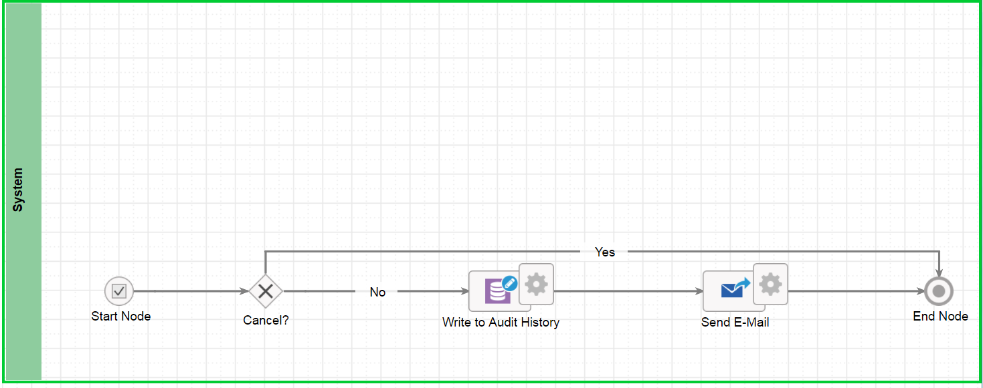

* + - 1. Update Application

Allows the user to validate checklist requirements, request a term change, or request a program change.

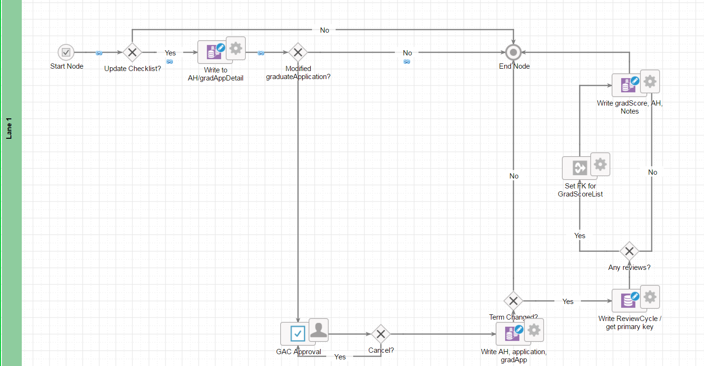

* + - 1. Expose Reviews

Allows the Director to show the all ratings submitted by faculty Reviewer to faculty reviewers rating the applicant.

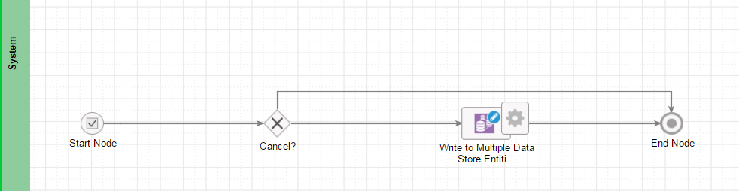

### **Graduate Admissions Dashboard**

The UAP application ultilises three dashboards, namely the Director Dashboard, the Faculty review Dashboard and the Graduate Admissions Coordinator Dashboard, which are accessible via Reports in Tempo . The users can see their respective dashboards under Graduate Admissions Dashboard.

* + - * 1. Director Dashboard

Provides a high level overview of applicants in the Graduate Admissions process

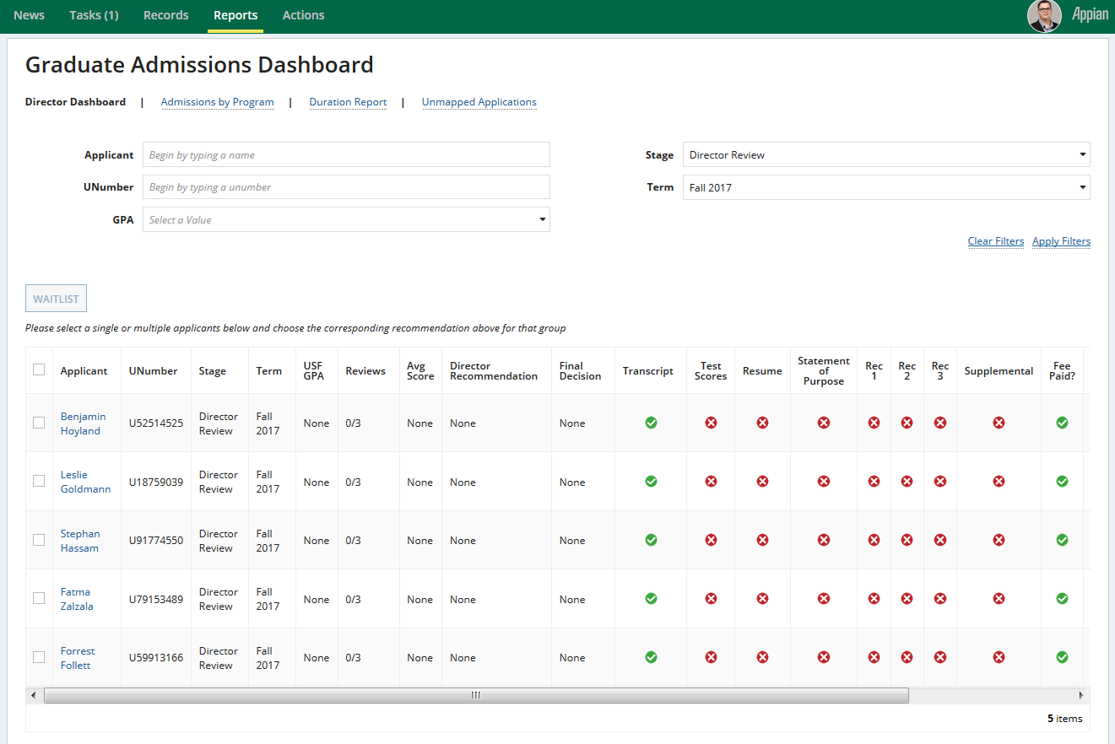

* + - * 1. Faculty Reviewer Dashboard

Provides a high level overview of applicants to be reviewed in the Graduate Admissions process

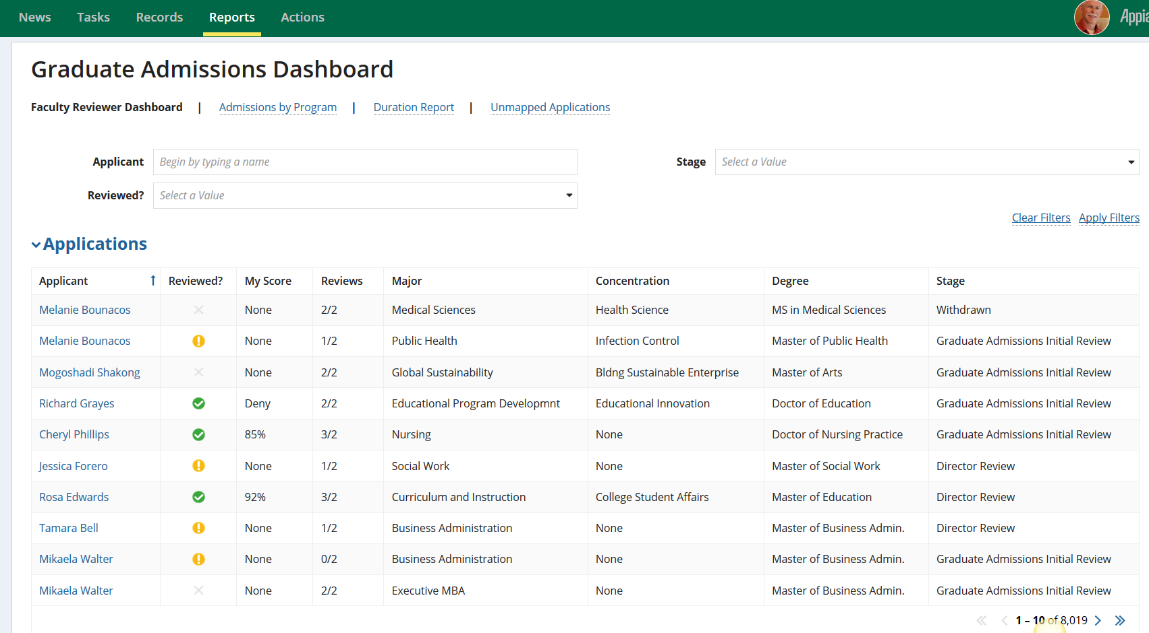

* + - * 1. Graduate Admissions Coordinator Dashboard

Provides a High level overview of applicants for Graduate Admissions Coordinators.

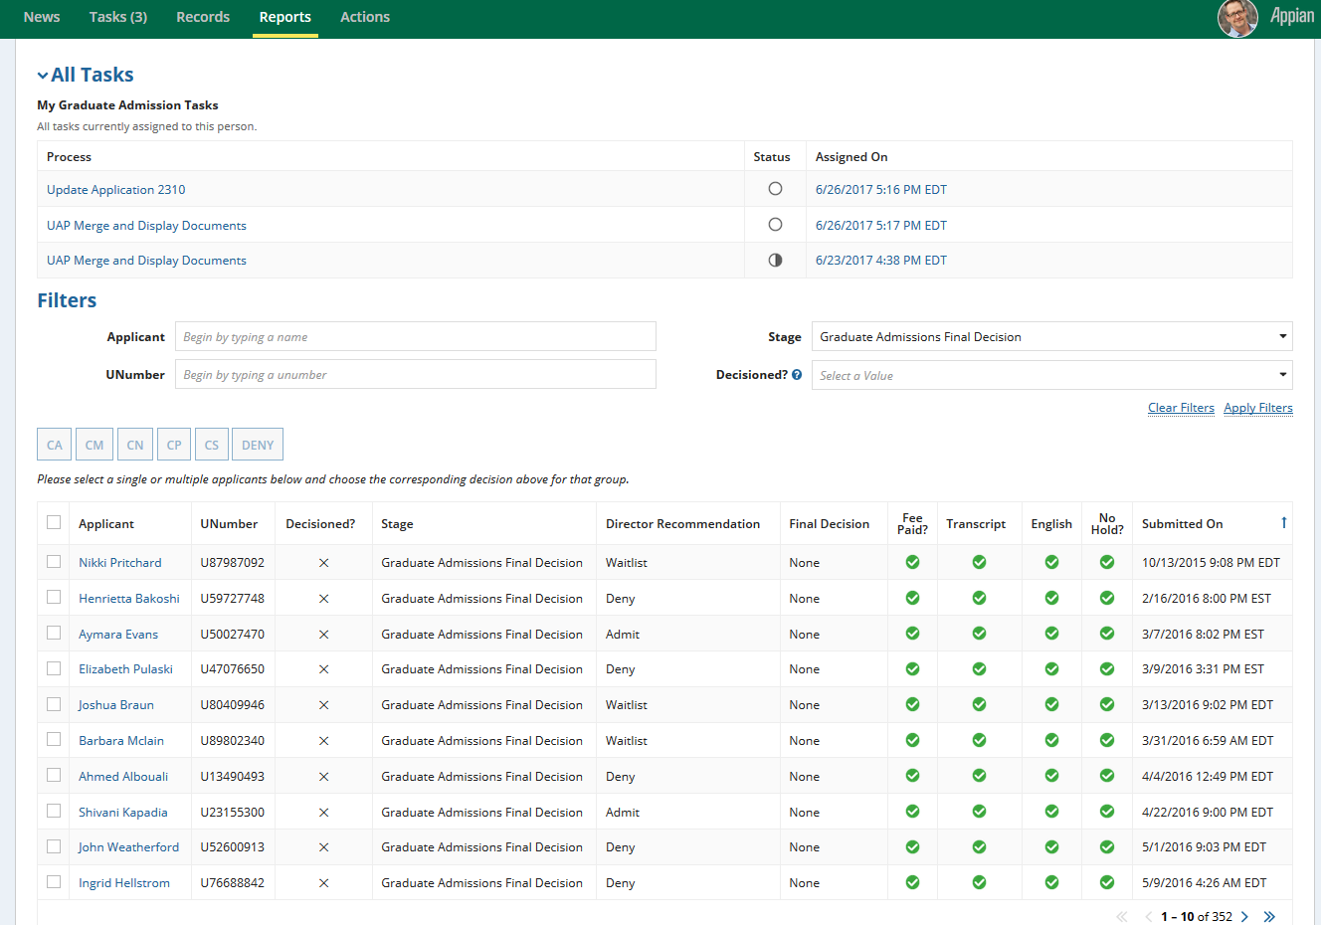

# Development Patterns

## Background Information

The information below shows development patterns Appian developers should adhere to when building the UAP.

### **Process Model and Rule Folder Structure**

#### Process Models

* All UAP Process Models are stored in the “UAP Process Models” folder.
* All Process Display names shall begin with “UAP” in order to differentiate them from other process instances within the system

#### Rules

Under the high level “UAP Rules and Constants Folders” folder, we have the following:

* UAP Rules and Constants
  + UAP Interfaces
  + UAP Expression Rules
  + UAP Constants
  + UAP Query Rules

#### Collaboration

Under the high level “Communities”, we have the following:

* UAP Community
  + UAP Knowledge Center
    - UAP Images
    - UAP Process Reports
    - UAP Templates
    - UAP Temporary Folder

#### Naming Conventions

The naming conventions for objects within the University Admissions application are described below:

Objects, specifically those that require unique names, should use the prefix “UAP_” to identify them as a part of the University Admissions system. The following naming conventions should be used:

* *Application Packages*
  + UAP <Application Name>
  + UAP <Application Name - Sprint<#>>
* *Groups*
  + Groups should be named with the Application prefix and then a description of the Group as described below
    - UAP All Users
    - UAP Administrators
    - UAP <Role Specific Groups>
* *CDTs*
  + All CDT names will use the “UAP_” prefix, followed by the name of the type. The name of the CDT should use camelCase.
    - [Example - UAP_faculty]
  + CDT Namespace
    - urn:com:appian:types:UAP
* *Process Models*
  + Process Model Folders
    - [Example - UAP Web Services]
    - Process Model Folders should indicate at a high level, the grouping of related processes within the application and written as; UAP Name of process model folder.
* *Rules*
  + Expression Rule names should be camelCased with the Application prefix.
  + [Example - UAP_getApplicant]
* *Constants*
  + Constant names should be all capitalized (ALL CAPS) with the Application prefix.
  + [Example - UAP_PROCESS_STATUS_INDEX]
* *Process Variables*
  + Process variables should follow camelCase standards with the first letter lower.
  + [Example - pv!dateStarted]

## Quick Reference Guide

|  |  |  |  |
| --- | --- | --- | --- |
| **Identifier** | **Type** | **Example** | **Description** |
| V | Constant | UAP_V_DS_CALCULATION | View |
| T | Constant | (Labels) UAP_T_TITLE | Text |
| B | Constant | UAP_B_CANCEL | Boolean |
| N | Constant | UAP_N_NUMBER | Number |
| TIM | Constant | UAP_TIM_EXCEPTION_TIMER | Time Values |
| DOC | Constant | UAP_DOC_DOCUMENT_NAME | Document - General |
| DOCT | Constant | UAP_DOCT_TEMPLATE_NAME | Document - Template |
| GRP | Constant | UAP_GRP_DEVELOPERS | Group |
| USR | Constant | UAP_USR_LIST_OF_USERS | User(s) |
| PH | Constant | UAP_PH_DETAIL_TEXT | Placeholder |
| BTN | Constant | UAP_BTN_SUBMIT | Button |
| TYP | Constant | UAP_TYP_NAME_OF_TYPE | Reference Type ID |
| STYP | Constant | UAP_STYP_NAME_OF_SUBTYPE | Reference SubType ID |
| REF | Constant | UAP_REF_NAME_OF_REF_DATA | Reference Data ID |
| MSG | Constant | UAP_MSG_COMMENT_GRID | Empty Grid Message/Message |
| TT | Constant | UAP_TT_POINT_OF_CONTACT | Help ToolTip |
| FLDR | Constant | UAP_FLDR_ADD_FEATURE | Folder |
| ICON | Constant | UAP_ICON_IN_PROGRESS | Icon |
| RPT | Constant | UAP_RPT_ANALYSIS | Report |
| RT | Constant | UAP_RT_FEATURE_SET | Record Type |
| INS | Constant | UAP_INS_ADD_FEATURE_SET | Instructions |
| DS | Constant | UAP_DS_CDT_NAME | Data Store |
| PM | Constant | UAP_PM_ADD_FEATURE | Process Model |
| MS | Constant | UAP_MS_OVERALL | Milestone (Status) |
| KC | Constant | UAP_KC | Knowledge Center |
| VAL | Constant | UAP_VAL_ | Validation text |
| getXXX | Query Entity/Expression Rule | UAP_getFeature UAP_v_getView | Query entity |
| r | Interface | UAP_r_myTasks | Report |
| ch | Interface | UAP_ch_nameOfChart | Report |
| d | Interface | UAP_d_feature | dashboard |
| **Identifier** | **Type** | **Example** | **Description** |
| dv | Interface | UAP_dv_auditLog | Dashboard View (Not Summary) |
| s | Interface | UAP_s_details | section |
| f | Interface | UAP_f_createRequest | form |
| eg | Interface | UAP_eg_editableGrid | Editable Grid |
| pg | Interface | UAP_pg_pagingGrid | Paging Grid |
| c | Interface | UAP_c_component | Component |
| btn | Interface | UAP_btn_layout_name | Button Layout |
| MU | Mockup | UAP_MU_<identifier>_nameOfMockup | Mockups |
| validate | Expression Rule | UAP_validateStringLength | Validation |
| return | Expression Rule | UAP_returnDateTime | Return (anything not coming from a query) |
| format | Expression Rule | UAP_formatDateTime | Formats/manipulates data |
| u | Expression Rule | UAP_u_thisIsAUtility | utility |
| grl | Expression Rule | UAP_grl_gridRow | Grid Row Layout |
| ws | Expression Rule | UAP_ws_myExampleServiceApi | Web services |
| td | Expression Rule | UAP_td_taskDisplayName | Task Display name |
| pd | Expression Rule | UAP_pd_processDisplayName | Process Display name |
| v | Data Type | UAP_v_name_of_view | View CDT |

# Plugins

## Existing

### **AdvancedDocumentTemplating**

Smart Services included:

* DOCX Document from Template

### **Group Management Plugin**

Features:

* Getgroupprofile
* Group functions
* Group profile record

### **PDF Tools**

Functions:

* Pdftoolsfunctions

Smart Services:

* Compress PDF,
* Convert PDF To Image,
* Create PDF,
* Extract PDF Pages,
* Fill PDF,
* Merge PDF

Data Types

* PdfContent Data Type,
* PdfField Data Type,
* PdfImage Data Type,
* PdfMetadata Data Type,
* PdfText Data TypePDF Tools
  + 1. **People Functions**

Functions:

* DoesUserExist,
* GetGroupByName,
* GetGroupNames,
* GetGroupTypeName,
* GetGroupUUID,
* GetGroupsForAdminUser,
* GetGroupsForMemberUser,
* GetGroupsOfType,
* GetGroupsOfTypeForUser,
* GetGroupsOfTypeFromList,
* GetMemberGroups,
* GetMemberGroupsOfType,
* GetModifiedUsersByTimestamp,
* GetParentsOfGroup,
* GetUsersLastPasswordChange,
* IsUserActive,
* IsUserMemberOfAllGroups,
* IsUserMemberOfGroups,
* IsUserSystemAdministrator,
* RetrieveUserSecurityRoleMap

Smart Services:

* Add People As Group Admins

Data Types:

* UserSecurityRoleMap

### **Add Documents to Zip**

Smart Services:

* + Add Documents to Zip

### **Data Collection features of Appian Health Check**

Smart Services

* + DOCX Document From Template,
  + DOCX Document From Template [Deprecated]

### **Object Information Retriever**

Functions

* GetConstantOrRuleUUIDByName,
* GetContentDetailsByInternalName,
* GetContentDetailsByUUID,
* GetContentObjectDetailsByID,
* GetContentObjectsWithNumOfVersions,
* GetProcessModelDetailsByUUID

### **Appian Regular Expression Function**

Functions

* RegexAllMatches,
* RegexArrayIndexFirstMatch,
* RegexFirstMatch,
* RegexInsertMatchMarkers
* RegexMatch,
* RegexReplaceAll
* Function Categories:
* RegexFunctions

### **Business Value Framework Plugin Framework**

Smart Services:

* Delete Metric Smart Service
* Rebuild Metric Data Smart Service
* Record Milestone Smart Service

### **Content Expressions**

Functions:

* FindContentByAttribute,
* FindDocumentsByName,
* FindFoldersByName,
* GetConstantsFromFolder,
* GetDocumentInternalIdsFromFolder
* GetDocumentsFromFolder
* GetFilesLargerThanSize
* GetFilesOlderThanDate
* GetFolderSearchability
* GetSubfoldersFromFolder
* ReturnContentRolemap
* SetFolderSearchability

Function Categories:

* Custom Content Functions

Data Types

* ContentSecurityRoleMap

### **Crypotography**

Functions:

* Hasher

Function Categories:

* Cryptography Function

## Custom

### No custom plugins were used for this application.

# Data Design

## High Level Data Design

The lookup table used in this application is called “UAP_reference” listed below. The audit history table shares the same one as the Travel Application, “TRV_auditHistory”. All other UAP tables are detailed in the ERD below. Please zoom in to see the details of the ERD table.

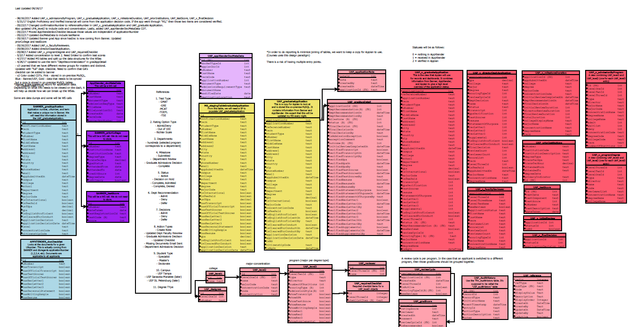

## UAP Data Design

Within the UAP, all CDT names will use the “UAP_” prefix, followed by the name of the type. The name of the CDT should use camelCase, with the first letter in lowercase.

All the CDTs for the UAP should use the following namespace: “urn:com:appian:types:UAP”.

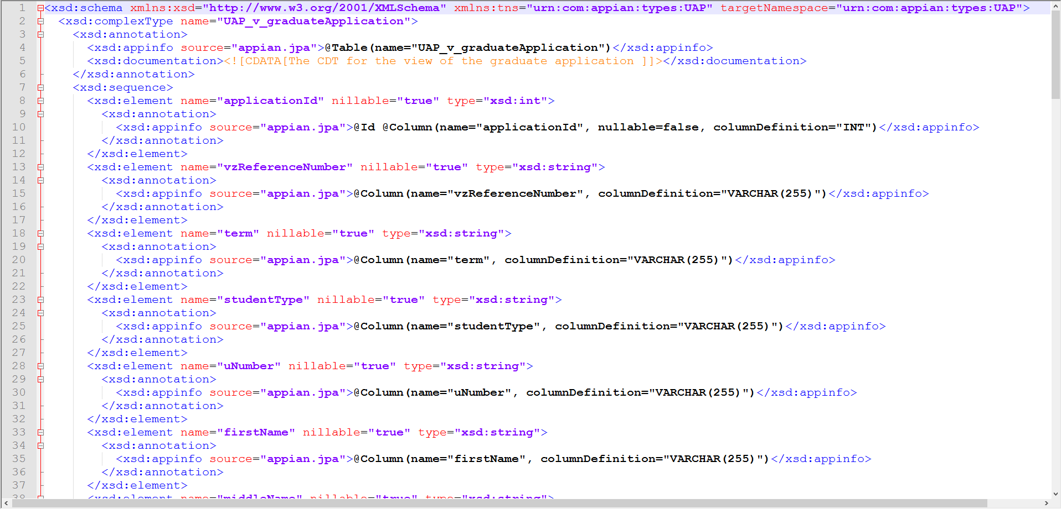

# Groups

This section contains a list of Appian groups and their hierarchy. Below is an example of how the groups are organized.

This section contains a list of Appian groups and their hierarchy. As groups are nested under other groups, only unique permissions that were not inherited from the parent group. Additional security is implemented within the application itself based on the details of the application. Most of the related actions are not restricted by groups, but rather by the details of the application itself.

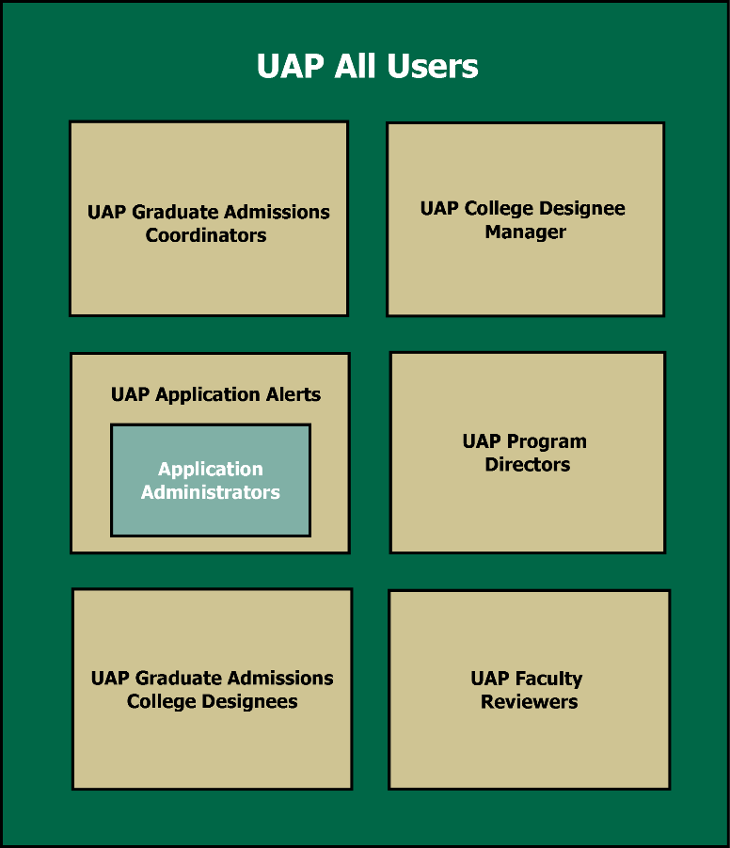

Figure . Displaying the UAP Groups.

## UAP All Users

### **Description**

All Users who are part of the Graduate Applications application.

### **Inherited Roles**

* + - 1. Graduate Admissions College Designees
      2. UAP Applications Administrators
      3. UAP Application Alerts
      4. UAP College Designee Managers
      5. UAP Faculty
      6. UAP Faculty Reviewers
      7. UAP Graduate Admissions Coordinator
      8. UAP Program Directors

### **Permissions**

#### Actions

Not applicable

#### Related Actions

##### Add Note

Allows the user to enter a note for an applicants Record.

#### Record Views

All Graduate Admissions applicants are visible to the UAP All Users.

#### Reports

Not applicable.

## UAP College Designee Managers

### **Description**

The UAP College Designee Managers are responsible for using the Manage Groups action to select users for the Graduate Admissions College Designees group.

### **Inherited Roles**

#### UAP All Users

### **Permissions**

#### Actions

##### Manage Designees

Allows the user to manage the Designees for the Colleges at USF.

#### Related Actions

Add Note

#### Record Views

The record that contains information about Graduate Applications.

#### Reports

Allows the user to view the Faculty Reviewer Dashboard under Graduate Admissions Dashboard.

## Graduate Admissions College Designees

### **Description**

Graduate Admissions College Designees can Manage Program Preferences for Programs that fall under their college. This includes updating the requirements that show up on the checklist grid, managing Program Directors, and managing Faculty Reviewers.

### **Inherited Roles**

#### UAP All Users

### **Permissions**

#### Actions

##### Manage Program Preferences

An action that allows the user to update the requirements that show up on the checklist grid, manage Directors, and manage Faculty Reviewers.

#### Related Actions

##### Add Note

Allows the user to attach a note to a Graduate Application’s Record Summary View.

##### Missing Documents Email

Allows the user to notify an applicant about any documents that they may be missing.

##### Update Application

Allows the user to verify program requirements for an application.

#### Record Views

##### Graduate Applications

The record that contains information about Graduate Applications. They can add notes from here.

#### Reports

Graduate Admissions Dashboard: Main Dashboard for all graduate admissions activities. The user can see the Directors dashboard.

## UAP Graduate Admissions Coordinators

### **Description**

UAP Graduate Admissions Coordinators are responsible for verifying Transcripts, English Proficiency, and Conduct Clearance. They’re also the final deciding factor in a decision, but they make their decisions based on the inclusion of the requirements above. They are essentially the final approval step as a safety net. The Program Directors make the subjective decision about whether to let them in.

### **Inherited Roles**

#### UAP All Users

### **Permissions**

#### Actions

##### Manage Admissions Groups & Preferences

This person can Manage process Designee.

#### Related Actions

##### Add Note

Allows the user to attach a note to a Graduate Application’s Record Summary View.

##### Missing Documents Email

Allows the user to notify an applicant about any documents that they may be missing.

##### Update Application

Allows the user to verify program requirements for an application. The GAC is the only role that can verify Transcript, English Proficiency, and Conduct Clearance.

#### Record Views

##### Graduate Applications

The record that contains information about Graduate Applications. They can add notes and verify requirements from here.

#### Reports

##### Graduate Admissions Dashboard

Allows the GAC to view the high-level information about applications important to them in their respective Graduate Admissions Coordinator Dashboard.

## UAP Faculty

### **Description**

This group is used to populate the UAP All Users group.

### **Inherited Roles**

#### UAP All Users

### **Permissions**

#### Actions

##### Manage Designees

Allows the user to manage the Designees for the Colleges at USF.

#### Related Actions

##### Add Note

Allows the user to attach a note to a Graduate Application’s Record Summary View

##### Faculty Review

Allows the user to add or edit a review for an application. They can rate it using the Degree’s scoring type and leave an optional note. These reviews are considered by Directors when making their decision.

#### Record Views

##### Graduate Applications

The record that contains information about Graduate Applications. They can add notes and verify requirements from here.

#### Reports

##### Graduate Admissions Dashboard

Allows the Faculty user to view the high-level information about applications important to them in their respective Faculty Reviewer Dashboard.

## UAP Faculty Reviewers

### **Description**

UAP Faculty Reviewers can review applications for the Programs that they’re specified for. Faculty Reviewers are determined by College Designees in the Manage Program Preferences action.

### **Inherited Roles**

#### UAP All Users

### **Permissions**

#### Actions

Not applicable

#### Related Actions

##### Add Note

Allows the user to attach a note to a Graduate Application’s Record Summary View

##### Faculty Review

Allows the user to add or edit a review for an application. They can rate it using the Degree’s scoring type and leave an optional note. These reviews are considered by Directors when making their decision.

#### Record Views

##### Graduate Applications

The record that contains information about Graduate Applications. They can add notes and verify requirements from here.

#### Reports

##### Graduate Admissions Dashboard

Allows the Faculty Reviewer user to determine which applications they need to act on/review in their respective Faculty Reviewer Dashboard.

## UAP Program Directors

### **Description**

UAP Program Directors are responsible for entering and transmitting the final decision on whether to admit or deny an applicant to a program.

### **Inherited Roles**

#### UAP All Users

### **Permissions**

#### Actions

##### Manage Program Preferences

An action that allows the user to update the requirements that show up on the checklist grid, manage Directors, and manage Faculty Reviewers.

#### Related Actions

##### Add Note

Allows the user to attach a note to a Graduate Application’s Record Summary View.

##### Director Recommendation

Allows the director to make a recommendation on behalf of their program for a graduate application

##### Expose Review

Allows each reviewer to see the reviews made for a specific applicant. Update Checklist

Allows the user to verify requirements for an application.

##### Missing Documents Email

Allows the user to notify an applicant about any documents that they may be missing.

##### Update Application

Allows the user to verify program requirements for an application.

#### Record Views

##### Graduate Applications

The record that contains information about Graduate Applications. They can add notes and verify requirements from here.

#### Reports

##### Graduate Admissions dashboard

Allows the Director to view the high-level information about applications important to them

## UAP Application Alerts

### **Description**

This group receives alerts for the Graduate Applications application

### **Inherited Roles**

#### UAP All Users

* + - 1. UAP Applications Administrators

### **Permissions**

#### Actions

Not applicable

#### Related Actions

Not applicable

#### Record Views

Not applicable

#### Reports

Not applicable

## UAP Application Administrators

### **Description**

UAP Application Administrators have Administrative privileges for the Graduate Admissions application

### **Inherited Roles**

#### UAP All Users

### **Permissions**

#### Actions

##### Manage Designee

Allows the user to manage the Designees for the Colleges at USF.

#### Related Actions

##### Add Note

Allows the user to attach a note to a Graduate Application’s Record Summary View.

##### Faculty Review

Allows the user to leave a review for an application. They can rate it using the Degree’s scoring type and leave an optional note. These reviews are considered by Directors when making their decision. Application Administrator are able to access Faculty Reviews for testing purpose.

#### Record Views

##### Groups

The user can update group’s members of Graduate Admissions Coordinators via Records-Groups-UAP Graduate Admissions Coordinators- Related Action-Update Group.

#### Reports

##### Graduate Admissions dashboard

# UX Patterns

This section contains a list of UX patterns to be adhered to when developing.

## Action Buttons on Dashboards

The icons and the words are both safe links that point to the same place.



**Coming Soon**

## Reports & Charts

Reports attempt to use USF colors where possible. They also have dropdowns to help filter the data.

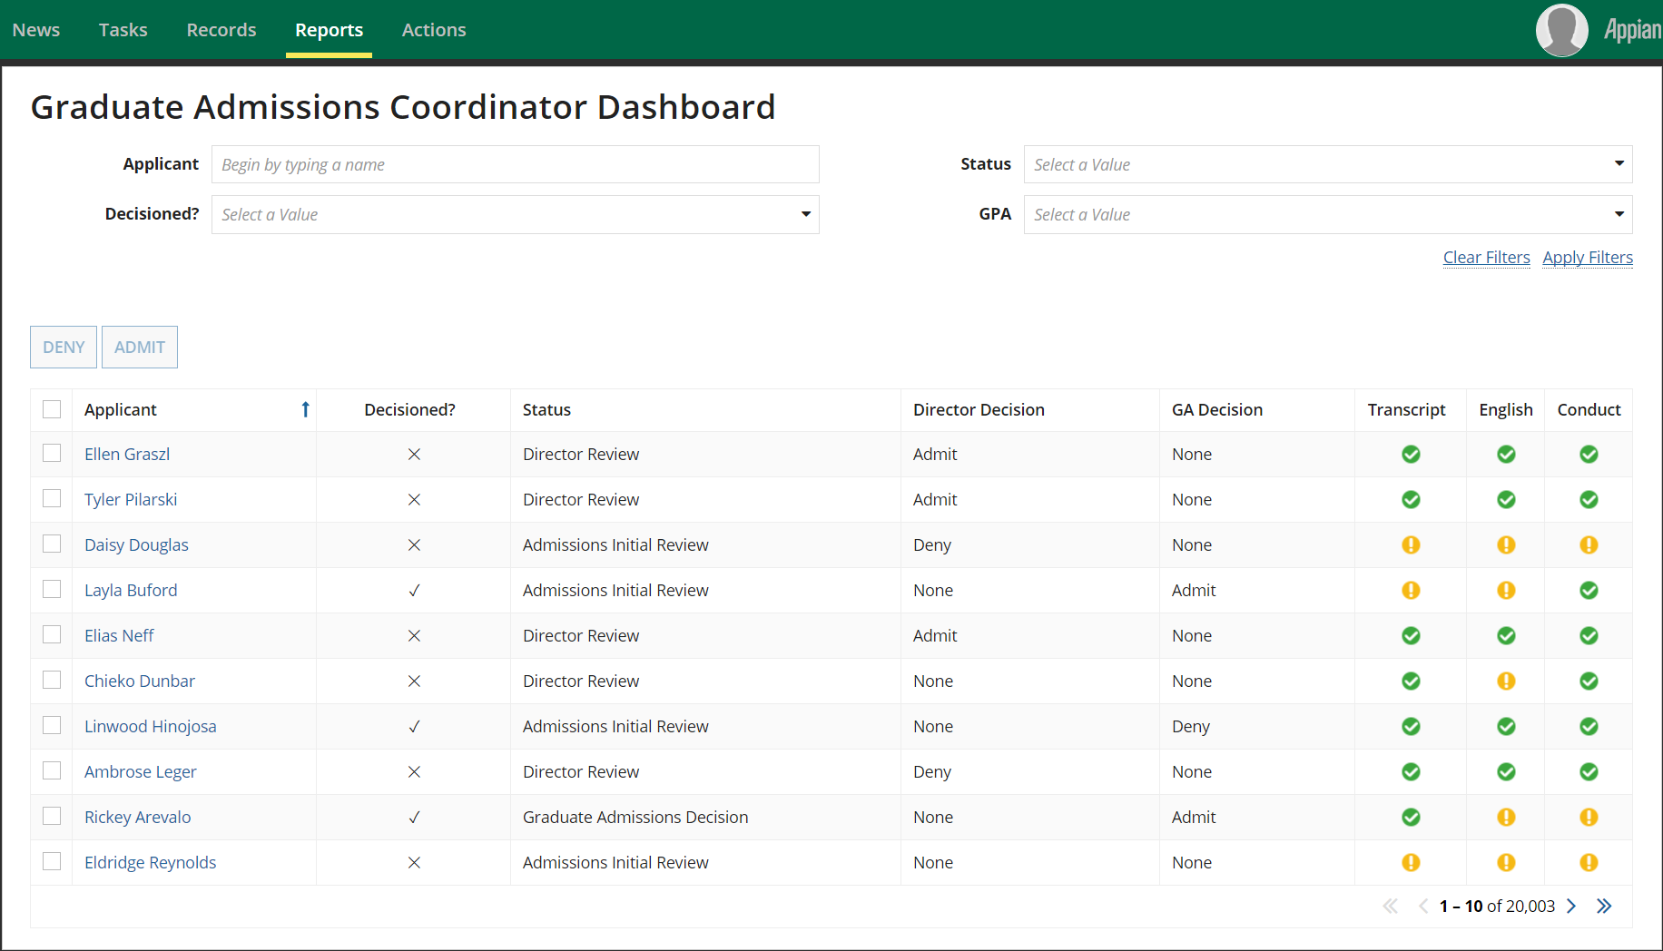

## Dynamic Email Names

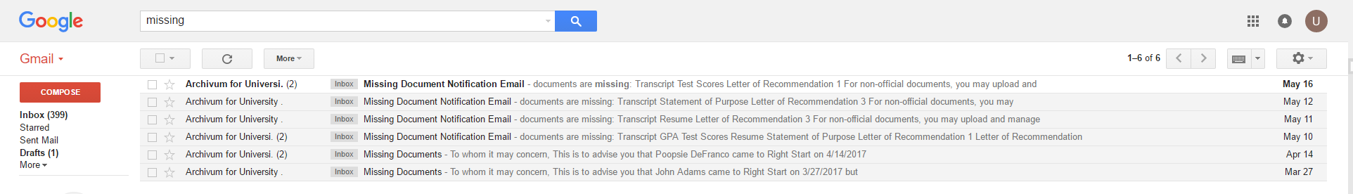

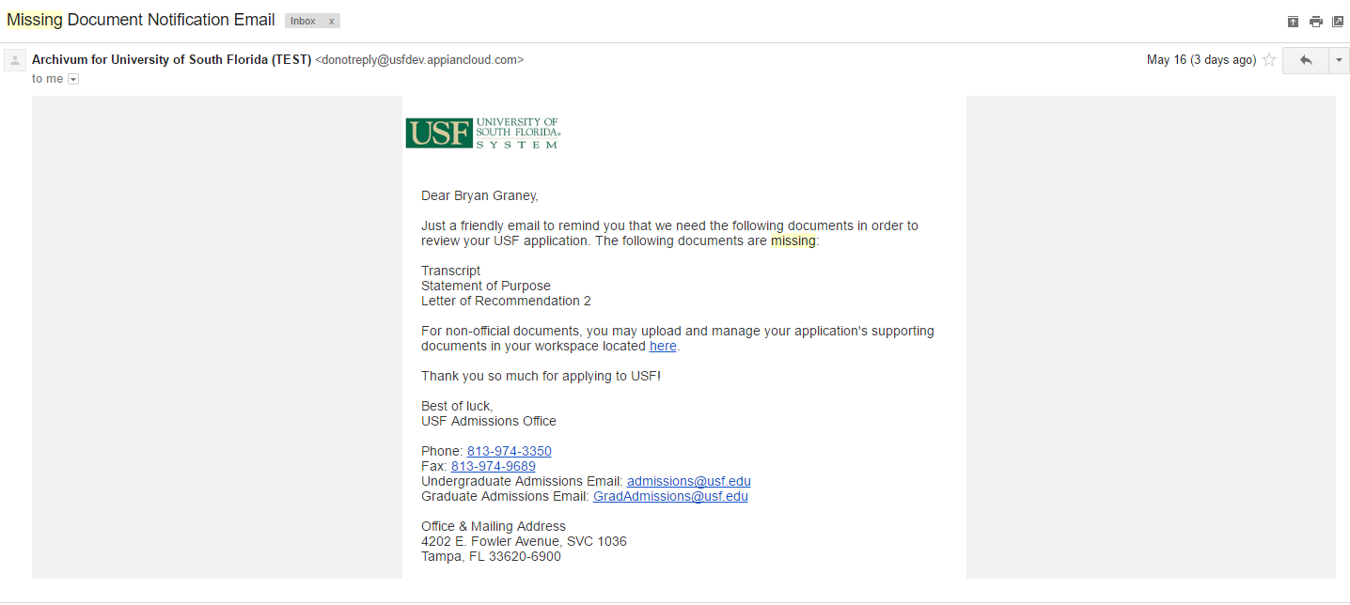

## Collapsible Sections

All sections are collapsible. 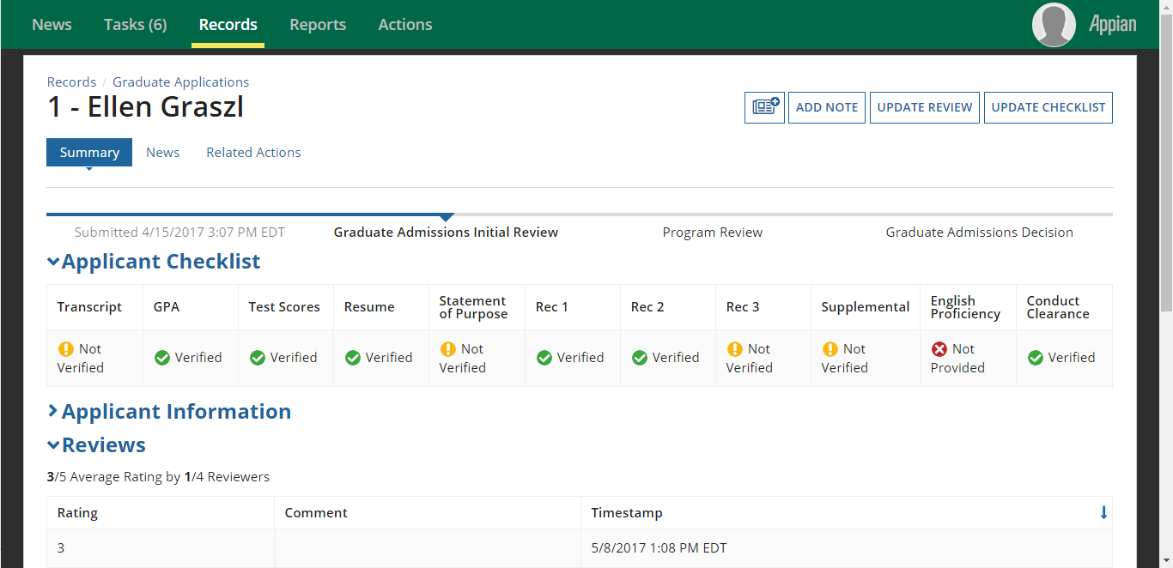

# Integrations

The UAP integrates with the following systems via MuleSoft: Banner (Application Data) and AppXtender (Document Receipt & Document Data),

Sample of these web services can be viewed from the MuleSoft API Console.

|  |  |
| --- | --- |
| Console URL | https://ux-appian-student-uat.cloudhub.io/console/ |
| client-id | af066030e05446ebaae33a45854182a9 |
| client-secret | B39619F63d384E8Fa476D902c212a51F |

## Get Prior Institutions

### Description

All applicant information is sourced from BANNER

### Inputs

|  |  |  |  |
| --- | --- | --- | --- |
| **Data Point** | **Description** | **Type** | **Example** |
| usfId | USF Number | Text | U28100918 |
| initRow | Start Index | Int | 1 |
| maxRows | Batch size | Int | 10 |

### Outputs

|  |  |  |  |  |  |
| --- | --- | --- | --- | --- | --- |
| **Data Point** | **Description** | **Type** | **Example** | Appian Mapping | Banner Field Name |
| uNumber | USF Number | text | U28100918 | UAP_priorCollege.uNumber |  |
| institutionCode | Code for the institution | text | 1235 | UAP_priorCollege.institutionCode | sordegr_SBGI_CODE |
| institutionDescription | Institution Name | text | Florida State University | UAP_priorCollege.institutionName | stvsbgi_desc |
| degreeType | The name of the degree type | text | Master's | UAP_priorCollege.degreeType | sordegr_degc_code |
| transferGpa | GPA of the prior College | text | 3.7 | UAP_priorCollege.gpa | sordegr_gpa_transferred |
| transferHours | Number of transfer hours | text | 124 | UAP_priorCollege.transferHours | sordegr_X |
| attendedFrom | Date from | text | 4/28/2012 | UAP_priorCollege.attendedFrom | sordegr_attend_from |
| attendedTo | Date to | text | 4/15/2014 | UAP_priorCollege.attendedTo | sordegr_attend_to |
| degreeDate | Degree Awarded | Text | 6//12/2016 | UAP_priorCollege.degreeDate | sordegr_degc_date |
| primaryIndicator | primaryIndicator | Boolean | TRUE | UAP_priorCollege.isPrimary | sordegr_primary_ind = 'Y' |
| isOfficialTranscript | Text | Text | True | UAP_priorCollege.isDegreeAwarded | sorpcol_official_trans |

Sample Response Body:

{

"responseCode": 0,

"responseMessage": "Data retrieved successfully",

"data": [

{

"firstName": "Pryor",

"middleInitial": "In",

"lastName": "Stutions",

"usfId": "U12345678",

"priorInstitutions": [

{

"institutionCode": "001392",

"institutionDescription": "Manchester CC - CT",

"degreeType": "000000",

"transferGpa": 3.7,

"attendedFrom": "1989-05-01T00:00:00",

"attendedTo": "1990-05-01T00:00:00",

"degreeDate": null,

"primaryIndicator": null

}

]

}

],

"errors": []

}

## Get Test Scores

### Description

All test scores information is sourced from BANNER, reviewing data from SWATEST.

### Inputs

|  |  |  |  |
| --- | --- | --- | --- |
| **Data Point** | **Description** | **Type** | **Example** |
| usfId | USF Number | Text | U28100918 |

### Outputs

|  |  |  |  |  |  |
| --- | --- | --- | --- | --- | --- |
| **Data Point** | **Description** | **Type** | **Example** | Appian Mapping | Banner Field Name |
| uNumber | USF Number | text | U28100918 | UAP_testScore.uNumber | spriden_id |
| testDate | Date test was taken | date | 3/1/2011 | UAP_testScore.testDate | sortest_test_date |
| testComponent | Test codes | text | AP69 | UAP_testScore.testComponent | GORADID_ADDITIONAL_ID |
| testScore | Official testscores | text | UGR1 | UAP_testScore.score | sortest_test_score |
| testDescription | Name of the test taken | text | Calculus BC | UAP_testScore.testDescription |  |

Sample Response Body:

{

"responseCode": 0,

"responseMessage": "Data retrieved successfully",

"data": [

{

"firstName": "Tes",

"middleInitial": "T",

"lastName": "Scoors",

"usfId": "U22222222",

"tests": [

{

"testComponent": "AP36",

"testDescription": "English Language and Comp",

"testScore": "3",

"testDate": "2015-05-01T00:00:00",

"request": null,

"source": "EDI"

},

{

"testComponent": "AP68",

"testDescription": "Calculus BC",

"testScore": "3",

"testDate": "2016-05-01T00:00:00",

"request": null,

"source": "EDI"

}

]

}

],

"errors": []

}

## Get Document Meta Data

### Description

This web service integration provides all the document details for a given UNumber

### Inputs

|  |  |  |  |
| --- | --- | --- | --- |
| **Data Point** | **Description** | **Type** | **Example** |
| usfId | USF Number | Text | U3826839 |

### Outputs

|  |  |  |  |  |  |
| --- | --- | --- | --- | --- | --- |
| **Data Point** | **Description** | **Type** | **Example** | Appian Mapping | Banner Field Name |
| uNumber | USF Number | text | U28100918 | UAP_testScore.uNumber | spriden_id |
| dateTaken | Date test was taken | date | 3/1/2011 | UAP_testScore.dateTaken | sortest_test_date |
| testRegistrationId | Registration ID for that test (unique identifier) | text | 123467 | UAP_testScore.testRegistrationId | GORADID_ADDITIONAL_ID |
| testCode | Unofficial GRE Verbal | text | UGR1 | UAP_testScore.testCode | sortest_tesc_code |

Sample Response

{

"responseCode": 0,

"responseMessage": "Data retrieved successfully",

"data": [

{

"docId": 3327412,

"usfId": "U74078511",

"documentType": "SCORES",

"termCode": "201708",

"applicationNumber": "1",

"admissionsRequirement": {

"code": null,

"description": null

},

"institution": {

"code": null,

"description": null

},

"confirmationNumber": "VZ0697585",

"numberOfObjects": 1,

"activityDate": "2017-01-31 06:06:45",

"modifiedDate": "2017-01-31 06:06:45"

}

],

"errors": []

}

## Get Document

### Description

Get an actual document from Banner AppXtender

### Inputs

|  |  |  |  |
| --- | --- | --- | --- |
| **Data Point** | **Description** | **Type** | **Example** |
| docId | Document Number | Text | 3327412 |
| initRow | Start Index | Int | 1 |
| maxRows | Batch size | Int | 10 |

### Outputs

Sample Response: 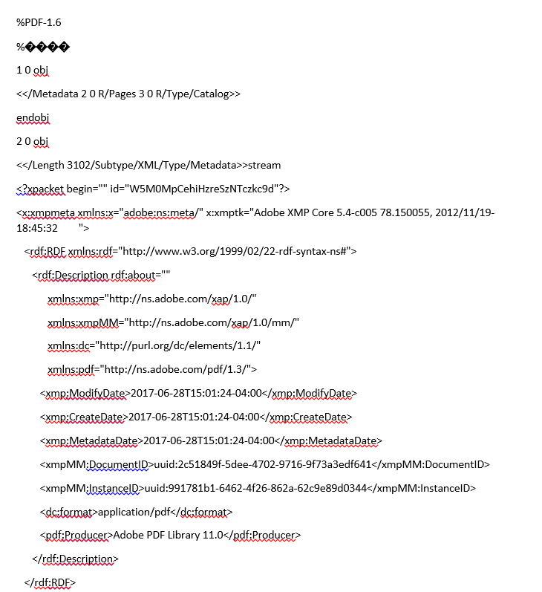

## Post Admission Decisions

### Description

Post Admission Decisions to Banner

### Inputs

|  |  |  |  |
| --- | --- | --- | --- |
| **Data Point** | **Description** | **Type** | **Example** |
| usfId | USF Number | Text | U28100918 |
| decisionCode | Admission Decision Code | Number | CA |
| applicationNumber | Application Sequence Number | Text | VZ001 |
| term | Term applying for | text | 201701 |
| admissionDecisionDate |  |  | 3/14/2017 |

### Output

Sample Response:

{

"responseCode": 0,

"responseMessage": "Data retrieved successfully",

"data": [

{

"usfId": "1",

"successful": "True",

"messages": [

"First Message",

"Second Message"

]

}

],

"errors": []

}

# Technical FAQS

## How do I assign Users to the Proper Groups?

* **UAP Graduate Admissions Groups that can simply be added to groups**
  + UAP Application Alerts
  + UAP All Users
  + UAP College Designee Managers
  + UAP Faculty
* **UAP Graduate Admissions Coordinator:**
  + Log in as a Group Administrator for the Graduate Admissions Coordinator group
  + Records -> Groups->UAP Graduate Admissions Coordinators
  + Related Actions->Add Members to Groups
  + Type in name in user picker
  + Add Groups
* **Graduate Admissions College Designee:**
  + Log in as a College Designee Manager
  + Actions->Manage Designees
  + Add user to selected Colleges
  + Submit
* **UAP Program Director**
  + Log in as a College Designee
  + Actions->Manage Program Preferences
  + Select the desired program
  + Clear out the Director
  + Type in name of desired user in Director user picker
  + Update Program
* **UAP Faculty Reviewer**
  + Log in as a College Designee
  + Actions->Manage Program Preferences
  + Select the desired program
  + Type in name of desired user in Faculty Reviewers user picker
  + Update Program

## Reference Table

* **Reference Table**
  + All standard reference data that supplies dropdown components, radio buttons, pickers, etc. is present in the UAP_reference table and inserted/updated by means of the ‘MASTER Insert Data’ SQL script.
* **Modifying Reference Data**
  + If reference data needs to be modified, its entry in the SQL statement should be edited and then rerun in the target environment.
  + If new reference data needs to be added, simply add a new row to the reference data table and rerun the script.
* **Removing Reference Data**
  + To remove reference data from appearing on the front end of the application, simply set isActive field to 0 (false) on the line(s) of reference data SQL desired to be set inactive.

## Security

The UAP application is particular when it comes to the security of Graduate Admissions Application and who can see specific sections of these applications, and the window in which they can see them. The User Permissions in the USF Graduate Admissions Application can be found on the BOX UAP Documentation.

To determine where security is set for a particular view of the application, or to see who has permissions for which actions within the application, the place to look is in the Graduate Application record. This record outlines all of the dashboard views and all of the related actions within the application.

## Term Changes

An application can be identified using a combination of the associated UNumber, Term, and Application Number. Therefore, when a term is changed, we cancel the existing application and create a new application that corresponds to the new Term. When we do this, we create copies of the Audit History, Reviews, Notes, and Details in addition to the Application object. We also populate the old application with a pointer to the new application (using the primary key in Appian) so that if the old application page is ever opened, we can provide a link to the new, updated application.

## Banner Sync

The unique combination of Unumber, Term, and Application Number is also used for the daily sync with Banner. We read from the staging table appiandb.BANNER_gradApplicant and update the UAP_graduateApplication and UAP_gradAppDetail tables accordingly. If the BANNER table has an applicationDecision value of ‘RG’ then we move the status from Initial Review to Director Review. We also use the applicationDecicion field to update the application status to Admitted, Denied, and Canceled.